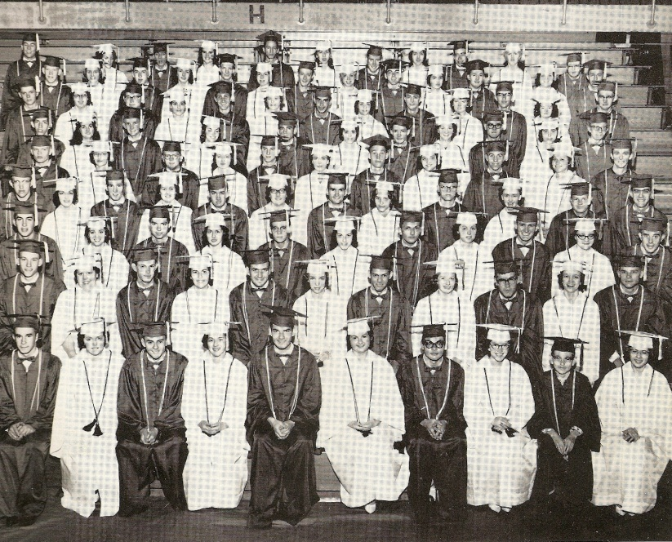
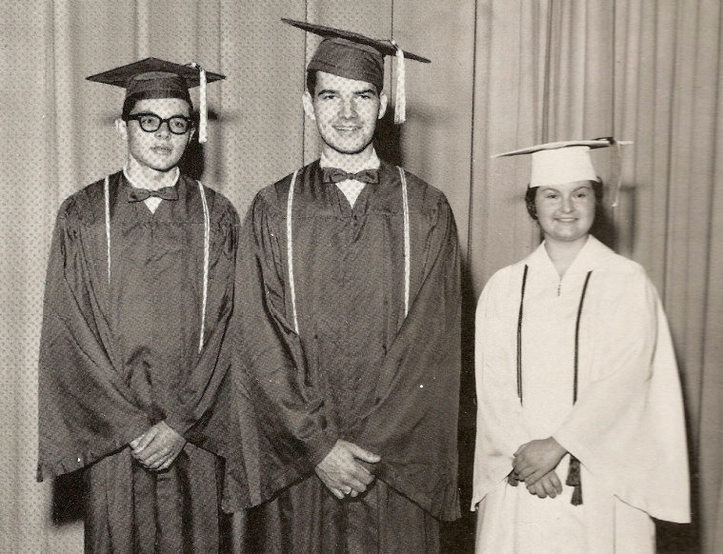
Charlestown High School Class of 1961
Commencement Exercises
Class Motto: “Not Finished, Just Begun”
Class Flower: “Yellow Rose”
Class Colors: “Mint Green and White”

On Tuesday, May 23, 1961, a large crowd watched the final and moving event of the school year, as the graduating Class of 1961 commencement was held at the Charlestown High School Gym. The program began with the invocation by Reverend Clifford Newby.
The Charlestown High School Chorus sang, “The Song of my Land.” Assistant principal Robert Myers then introduced the speaker of the evening, Mr. Morton Walker.
Later, Superintendent of Schools Alton Cochran was introduced by Myers, and he distributed the high school diplomas. Afterwards, Charlestown High School Principal Glen Ross gave out the awards and recognitions and Guidance Counselor Charles Nicholson gave out other awards to the students.
After a pause of a few moments, the high school chorus sang the “Alma Mater.” The Charlestown High School Band then joined with the choral group and sang, “You’ll Never Walk Alone.” The moment was filled with complete silence in the hall as the “Alma Mater” and “You’ll Never Walk Alone” was given by the voices of the choral group.
The Benediction was then given by the Reverend Clifford Newby. After he had finished with the closing prayer, the large audience in attendance heard the baritone voice of Tony Kochersperger as he sang “The Lord’s Prayer.” His rendering of this beautiful prayer in song for his classmates was very moving and inspirational. It was a very solemn occasion as it concluded the commencement exercises for the Class of 1961.
The beautiful Baccalaureate service was held on the preceding Sunday afternoon at 3 p.m. in the high school gymnasium. The event was also very moving and solemn as the Charlestown High School Class of 1961 seniors marched in to the processional march. All in the gym united in singing the hymn, “A Mighty Fortress.”
At the conclusion of the hymn, the invocation was given by Reverend Allen. “A Song of Praises” was immediately given by the Charlestown High School Chorus. Following this beautiful piece by the chorus, the Reverend Rufus Hickey came forth and proclaimed the Holy Scripture. When he had finished reading the passage the hymn “Holy, Holy, Holy” was sung by all present led by the chorus. Then the sermon was given by the Reverend Howard Chattin.
The high school chorus gave the Choral Benediction, and then it was time for the graduating Class of 1961 to form into a procession and march out of the gymnasium, concluding the beautiful event for the senior graduating class.
Graduating seniors were: Carmen Abbott, Darwin Abbott, Toni Adams, Carroll Adams, Tom Allen, Arthur Amburgey, Leon Armstrong, Richard Bailey, Janet Baird, Donald Barton, Larry Belcher, Robert Beller, Charles Bettler, Linda Birkla, Gwen Bottorff, Mary Bourne, Karen Bower, Roger Brading, Dennis Breidenbach, Walter Breidenbach, Judith Bridges, Judy Brown, Melvin Burns, Frank Bush,
Anna Marie Carlton, Phyllis Lee Carlton, Barbara Carter, Patsy Cassetty, Janet Ann Cheesman, Herman Collier, Albert Combs, Roger Combs, Sandra Conard, Phyllis Cooper, Judy Cummins,
Donald Dockter, George Doyle, Phillip Duncan, Michael Duty, Lois Eberle, Melvin Ferguson, Karen Francke, Barbara Fultz, Jeanette Gafnea, Betty Gibson, Edward Given, Raymond Given, Marilyn Grote,
Pat Hammonds, Charles Hardin, Larry Hardin, John Hartlage, Betty Hedges, Catherine Hobson, Barbara Hollowell, Terry Hover,
Martha Jackson, Barbara James, Wayman Jenkins, Juanita King, Claudine Kittrell, Doris Knies, Tony Kochersperger, Chuck Edward Ledbetter, James Leep, Carolyn Ann Lynn, David Lyons,
Clayton Martin, Billy Masingo, Paula Maymon, David McIntyre, Jerry McVicker, Velice Melton, Judy Montgomery, Steve Montgomery, Kay Moore, Jimmy Morgan, David Morrow, Carol Mudd, Bob Napier, Mitchell Newland, Sue Noble,
Marilyn Phillips, David Pierce, Eddie Pool, Jane Ratliff, Ruben Sanders, Rita Schafer, Delores Schindler, James Seals, Sandra Shields, Charles Small, Donald Smith, Gary Spencer, Charles D. Standifer, Jackie Stricker, Linda Taylor, Jewell Thomas, Ronnie Tobias, Freddie Lee Tungate, Ronald Tucker, Roger Wampler, Beverly Whitaker, Mickey Willey, Gary Wiggins, and Billy Young.

Honor students: Gary Wiggins, Valedictorian; Catherine Hobson, Ron Tobias, Co-Salutatorians.
Senior Class Officers: Frank Bush, Buddy Bettler, Judy Brown, Judy Montgomery, Rita Schafer.
Class sponsors: Mrs. Virgina Gladding and Jack Risinger.
Charlestown High School Principal: Glen A. Ross.

