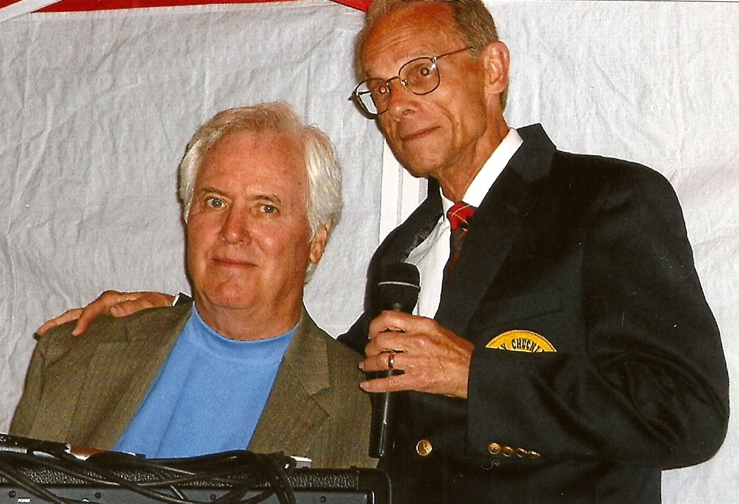
MUSIC MIXER – John Wall
and Chuck…the Classic Dj
Bring the original classic hits of the songs you love to listen and dance to at your next party mix!
Whether it be the ‘40’s – ‘50’s – 60’s – 70’s – 80’s – or beyond!
Music Mixer has entertained audiences of all ages with the number one memorable songs people enjoy!
Contact: John Wall at 1-812-944-6397 for bookings*
*rates: $400 (4hrs) - $350 (3hrs) - $300 (2hrs) all prices subject to change.
Most Recent Dance:
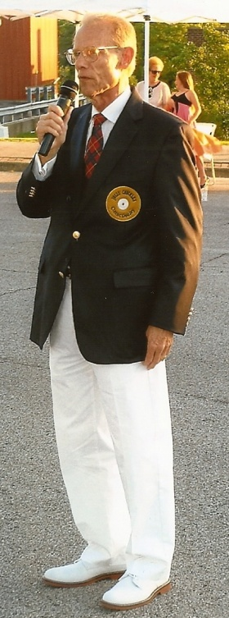
Second Annual Charlestown Street Dance a Success
“There’s a moon out tonight over Charlestown’s Street Dance,” Chuck…The Classic DJ (Ledbetter) tells his crowd on the Charlestown City Square as he introduces The Capris with their well-known hit of the same name as couples holding their hands head for the street to dance to one of their favorite oldies from the past.
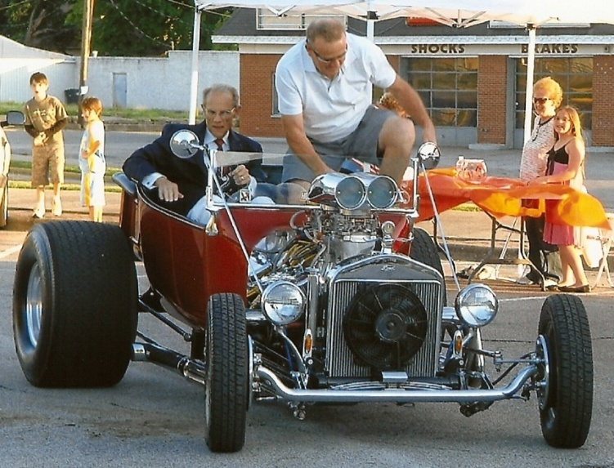
There were more classic hits to come as the DJ Party on the City Square was lit up at the beginning when Chuck …The Classic DJ rode into the dance in a suped-up hot rod classic car. The crowd that gathered for the event came to enjoy the evening and gave their appoval by applauding with delight as they saw the unexpected arrival of the deejay to the dance and marveled at the classic 1923 hot rod vehicle. The local DJ has been known as having surprising arrivals to dances and this was no exception. The audience was delighted. It was a night to be on the City Square.
Chuck...The Classic DJ
CTOWN.TV, the city’s online TV station, was on hand to video the event, and the TV production team got plenty of good shots with their TV cameras that citizens will be able to see in the near future.
Marvin Hodge, the owner of the classic car, said, “This is really fun! Let’s do it again! This event couldn’t have occurred at a better time in my life,” he said with delight. “Tomorrow (Sunday) my wife, Carol and I will be celebrating our 41st wedding anniversary.” Marvin was delighted “to be a part of it all.”
Chuck played many of the nostaligic tunes as well as dropping in the Electric Slide and the Cha Cha Slide to dance the night away. The young were dancing to many of the classic songs as well. One teenager wanted to hear Elvis’s “Jailhouse Rock” and another wanted to dance to Chuck Berry’s “Johnny B. Goode.” John wall of Music Mixer assisted Chuck in programming the nostalic tunes.
Sharon Taylor of Charlestown was the big winner of the night for just being at the dance. She had the winning ticket taking home several gift certificates from some of the leading businesses of Charlestown. Sharon received a $50.00 Gift Certficate from The Charlestown Pizza Company; $25.00 Gift Certificate from the Henderson Flower Shop, and a $15.00 Gift Certificate from the Copper Kettle Restaurant. It was a great time to be on Charlestown’s Square for the second annual street dance sponsored by the Charlestown Beautification Committee as part of Founder’s Day activities.
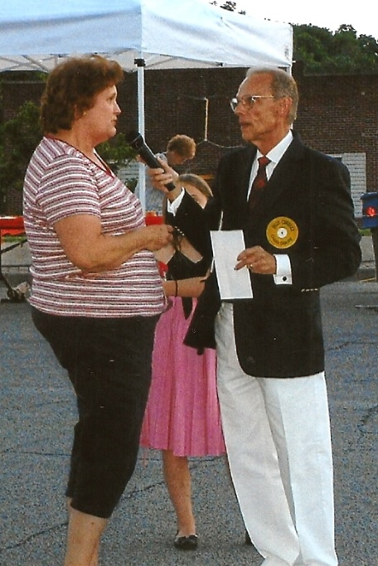
The City of Charlestown worked very hard to put the stage, picnic tables, and general cleaning of the area in shape for the event. The Charlestown Police Department played an integral part led by Chief Steve Dean taking care of traffic control and Charlestown Police Officer, Adam Clark, escorted the classic car with the deejay to the dance.
The street dance, which was held on Saturday, June 6, was part of a series of events organized by the Charlestown Beautification Committee to celebrate the city’s 201st Founder’s Day. The next scheduled event is the Balloon Glow with night-time hot-air ballons, music and vendors at the Charlestown State Park on June 19. The Charlestown Beautification Committee Founder’s Day weekend is June 26-27, with Founder’s Day Parade on Saturday, June 27.
Chuck...The Classic DJ asking Barbara Latuch of Charlestown if she knows the name and artist of the "Mystery Song."
John Wall of Music Mixer with Chuck...The Classic DJ at Charlestown's Second Annual Street Dance, Saturday, June 6, 2009

Artist Selections
Just some of the Doo Wop Artists Selections you can dance to: The Crests, The Chantels, The Platters, The Flamingos, Little Anthony & The Imperials, The Elegants, The Capris, The Dell Vikings, The Skyliners, Frankie Lymon & The Teenagers, The Mystics, The Duprees, Lee Andrews & The Hearts, Five Satins…and lots more!
Just some of the Rock ‘n Roll Artists Selections you can dance to: Elvis, Ricky Nelson, Pat Boone, Paul Anka, Buddy Holly & The Crickets, Frankie Avalon, Bobby Rydell, Bill Haley & His Comets, Fabian, Richie Valens, Big Bopper, Little Richard, Larry Williams, Gene Pitney, Little Willie John, Frankie Ford, Johnny Tillotson, Chuck Berry, Fats Domino, Ray Charles, Jerry Lee Lewis, Roy Orbison, Beach Boys…and lots more!
Just some of the Female/Girl Groups Artists Selections you can dance to: Connie Francis, The Shirelles, Wanda Jackson, The Supremes, Lesley Gore, Patience & Prudence, Brenda Lee, The Chordettes, Annette, The McGuire Sisters, LaVern Baker, Martha & The Vandellas, Sarah Vaughn, Fontaine Sisters, Dinah Washington, The Shangri-Las, Patsy Cline, Gale Storm…and lots more!
Just some of the POP Male/Female Artists Selections you can dance to: Johnny Ray, Kay Starr, Frank Sinatra, Rosemary Clooney, Perry Como, Pattie Page, Peggy Lee, Dean Martin, Doris Day, Andy Williams, Gogi Grant, Guy Mitchell, Teresa Brewer, Marty Robbins, Kate Smith, Bing Crosby, Jo Stafford, Tony Bennett, Dinah Shore, Johnny Mathis, Dionne Warwick, Nat “King” Cole, Eddie Fisher, Bobby Vinton, Johnny Cash, Frankie Laine…and lots more!
Just some of the Male Groups Selections you can dance to: The Diamonds, Four Aces, Four Lads, Mills Brothers, Jay & The Americans, The Drifters, The Lettermen, Billy Ward & The Dominoes, Four Seasons, The Impressions, The Temptations, Four Tops, The Bachelors, Four Preps…and lots more!
Just some of the Instrumental Group Selections you can dance to: Percy Faith & Orchestra, Lonnie Mack, Guy Lombardo, The Ventures, Glenn Miller, Les Elgart, Les Baxter, Lawrence Welk, Sammy Kaye, Tommy Dorsey, Jimmy Dorsey, Duane Eddy, Santo & Johnny, The Champs, Les Brown…and lots more!
Just some of the British Selections you can dance to: The Beatles, Dusty Springfield, Rolling Stones, Gerry & The Pacemakers, Dave Clark Five, Animals, Manfred Mann, Peter & Gordon, Herman’s Hermits, The Searchers, The Kinks, Chad & Jeremy…and lots More!
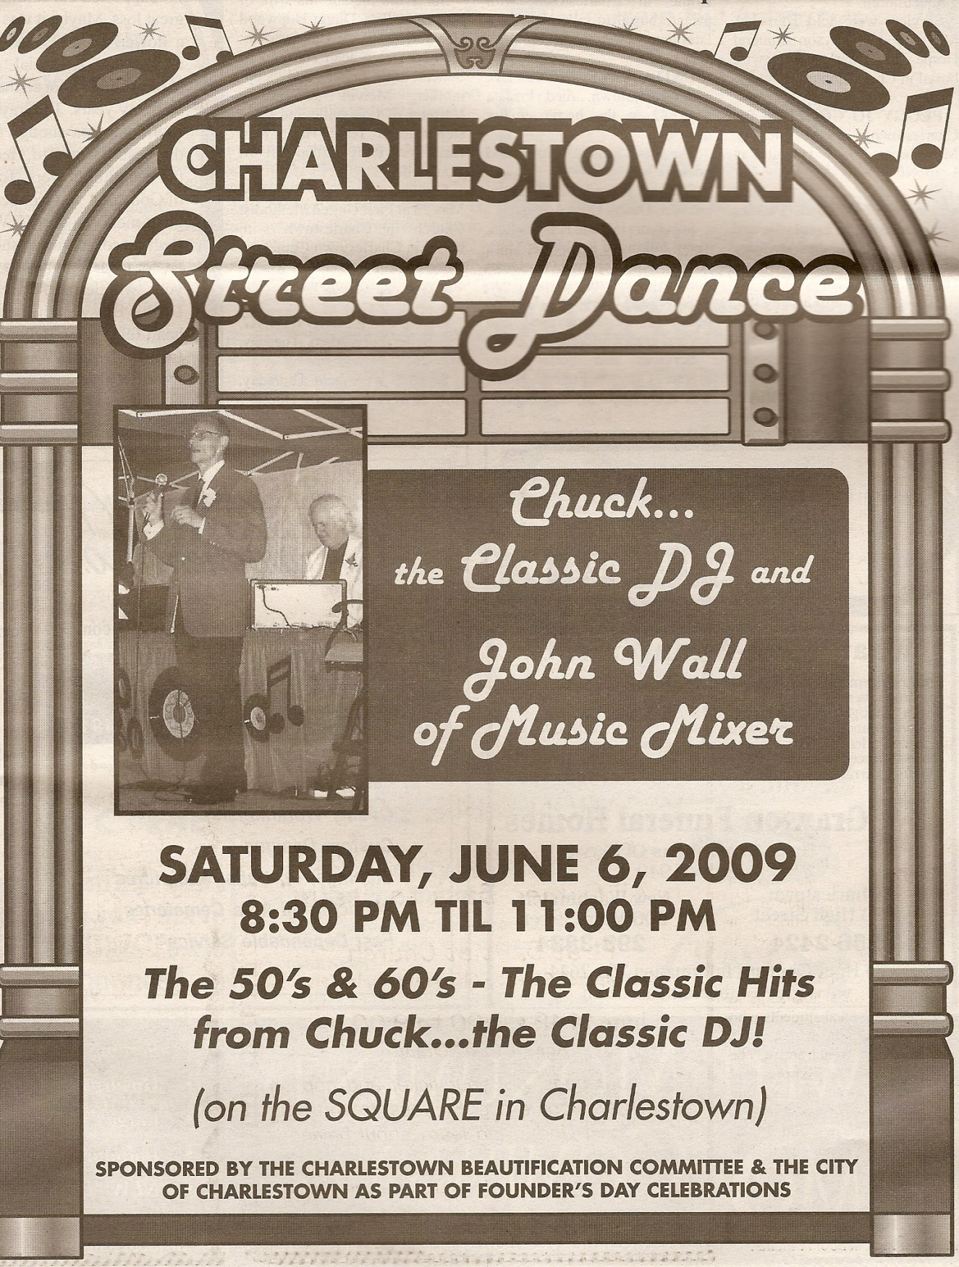
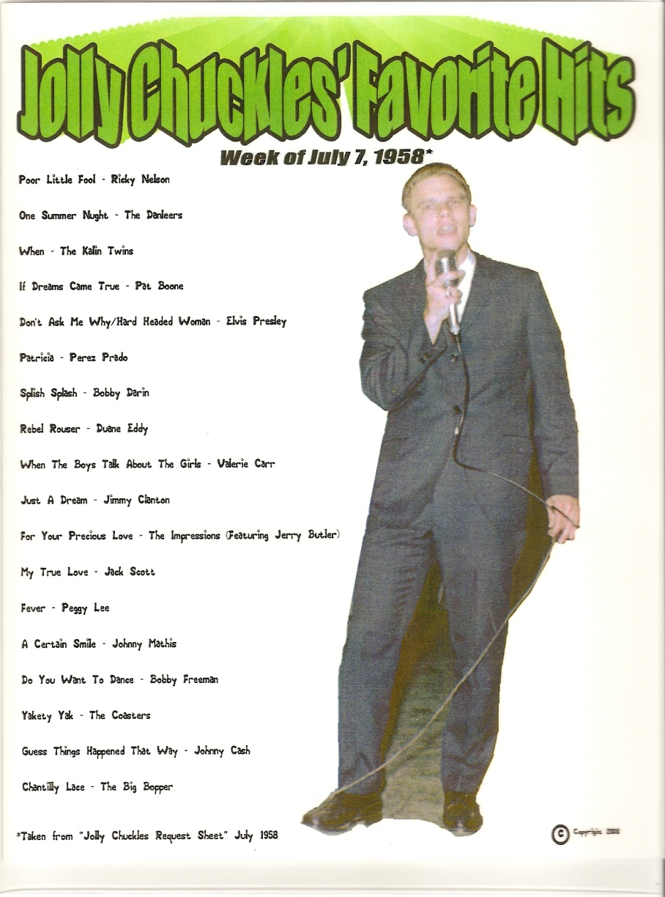
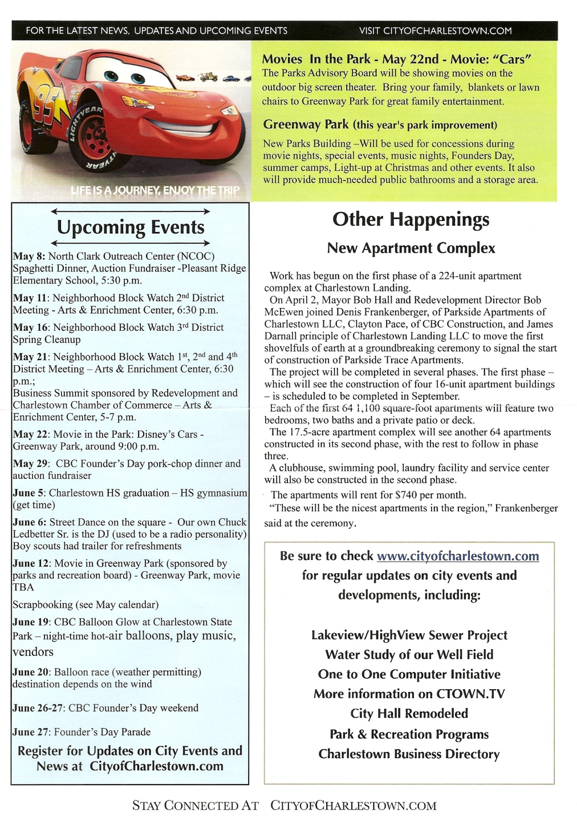
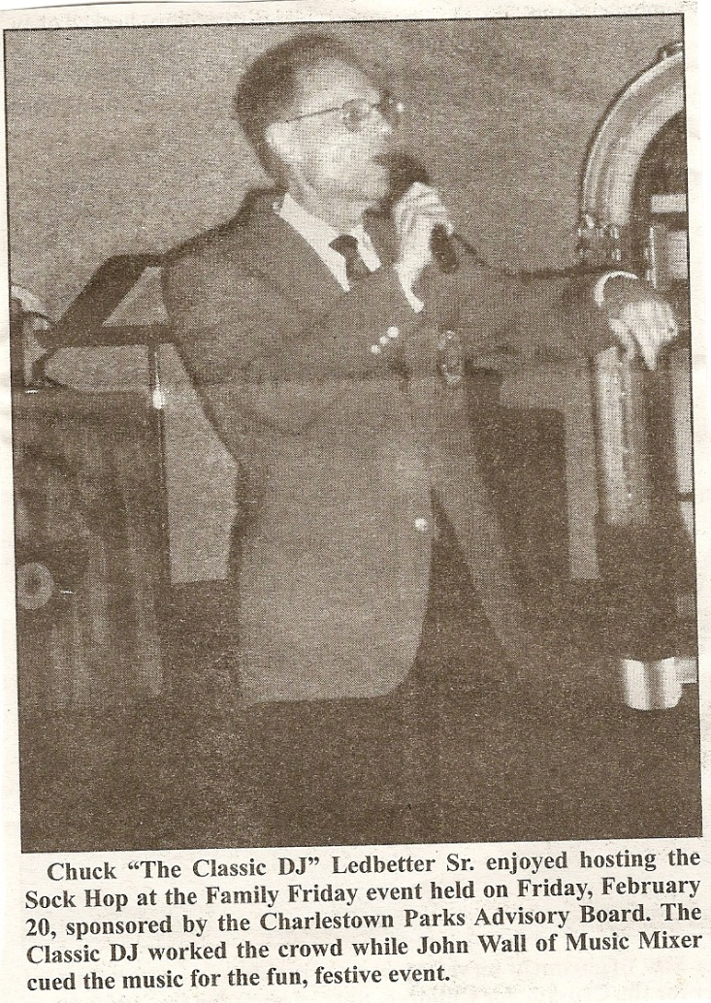

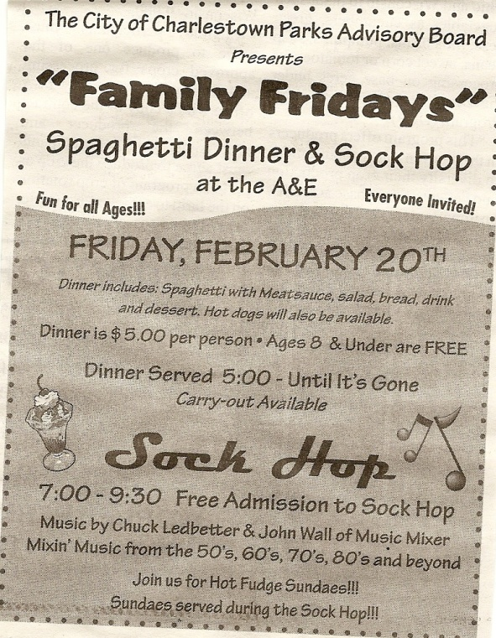
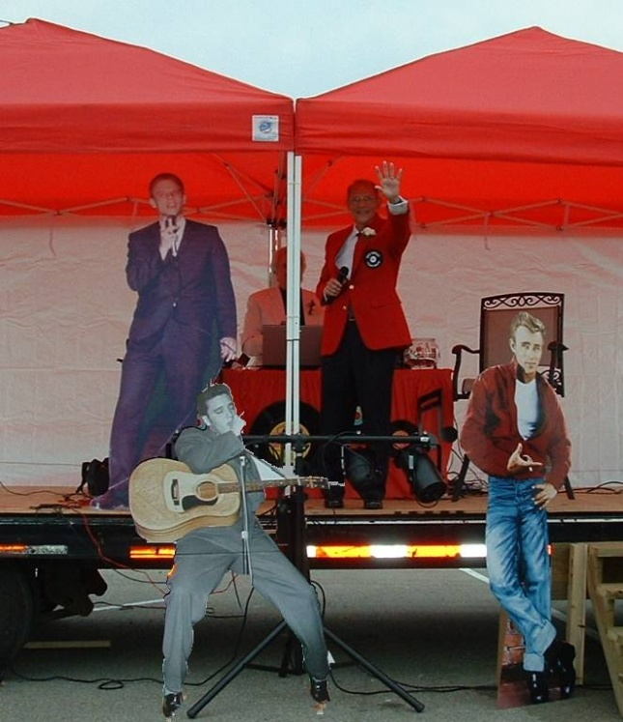
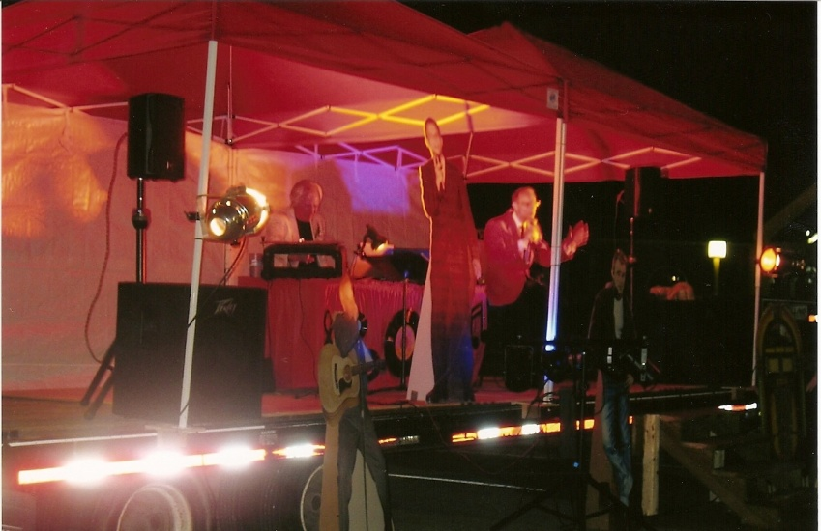

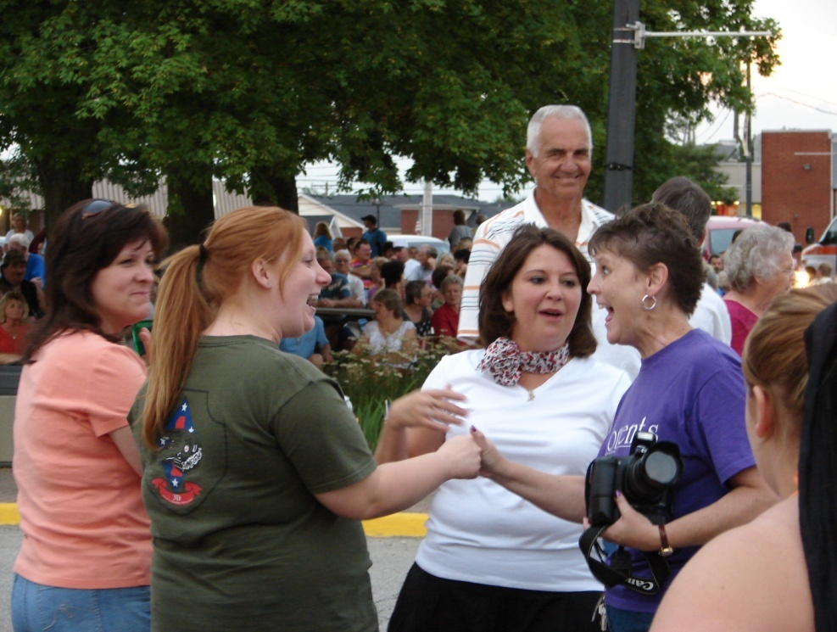

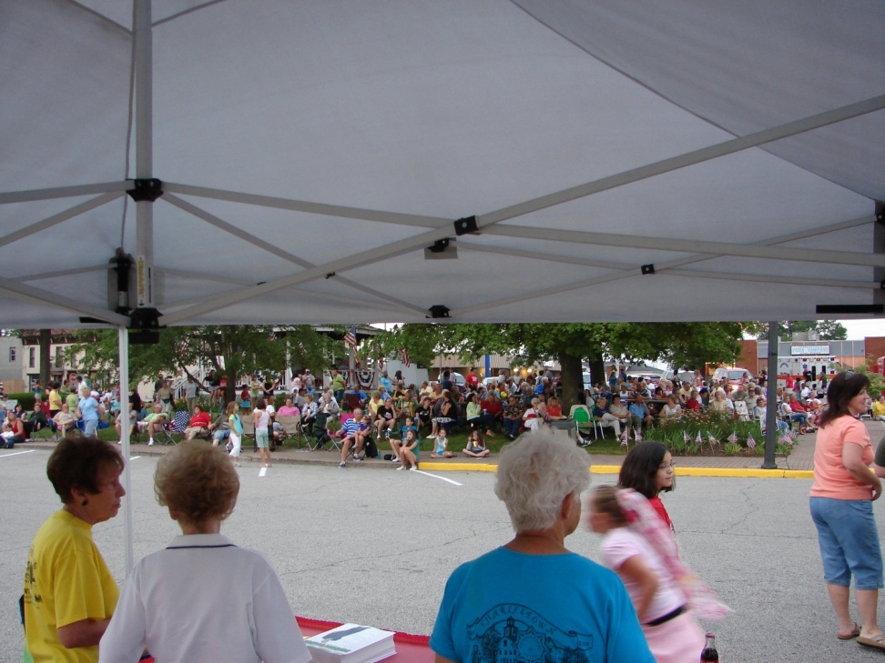

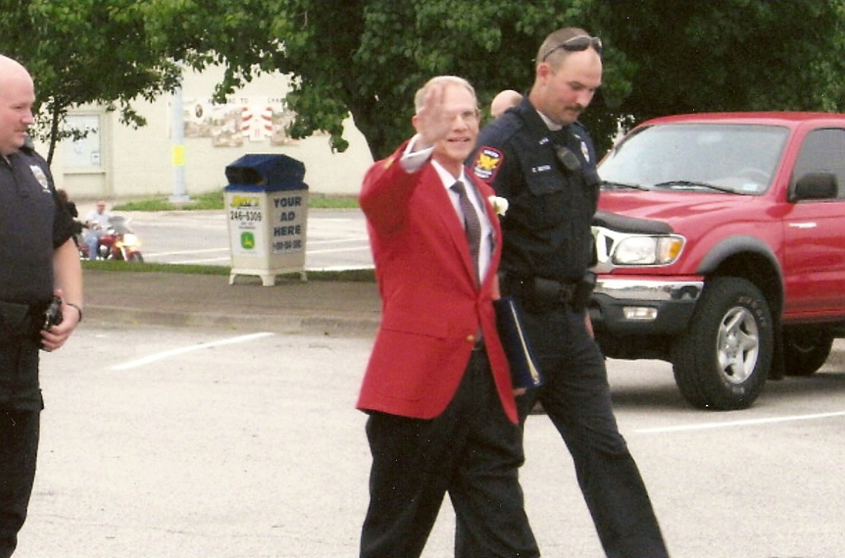

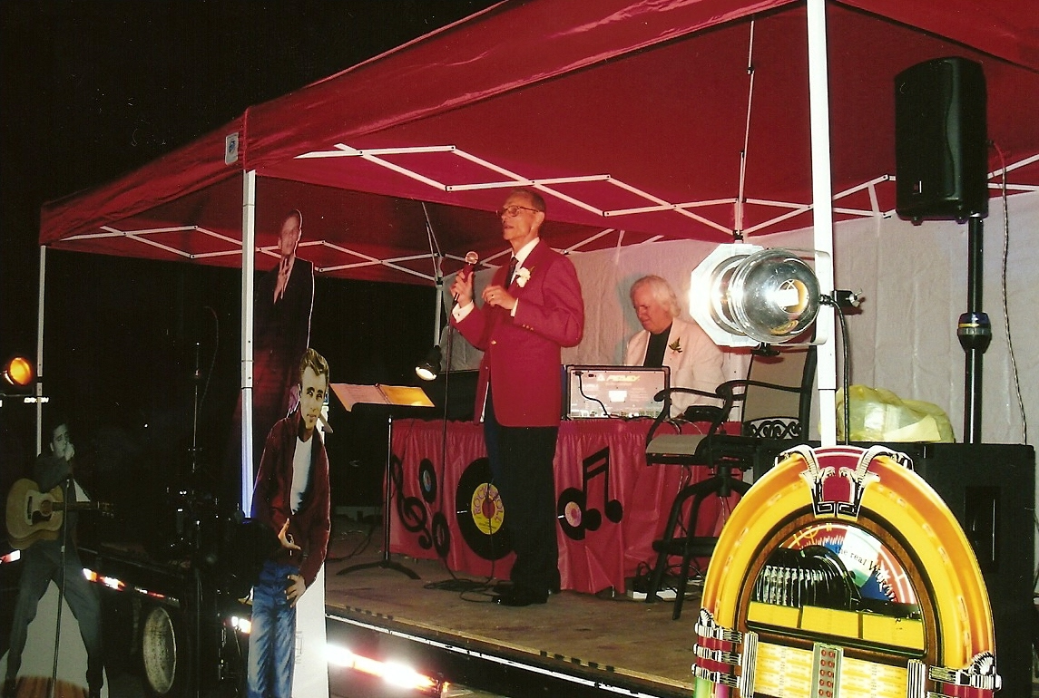
Chuck waving at crowd as Charlestown Police escorts him to stage at Charlestown’s Bicentennial Street Dance, Saturday, June 21, 2008
Chuck and John Wall of Music Mixer entertaining audience at Charlestown’s Bicentennial Street Dance, Saturday, June 21, 2008

